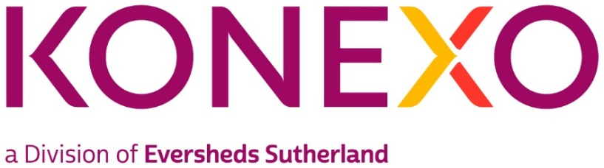

Administrator, Konexo
Practice group/Global Operations team: Konexo
Type of Vacancy: Permanent
Full time/Part time: Full-Time
Location: Leeds
About Konexo
Konexo is a global alternative legal and compliance provider developed by Eversheds Sutherland offering Legal, Compliance and HR services. Through clever use of emerging technology and resources, we connect clients’ needs with real benefits, and meet their challenges with transformative solutions.
We combine the heritage, strength and stability of being developed by a global law firm, with a highly flexible approach to problem solving.
We offer a full range of services including consulting, legal services which includes managed services, branding services, real estate services and interim resourcing support - all underpinned by advanced technology, smart systems, and bright minds. Konexo is present in the UK, US, Hong Kong, Singapore and Malaysia
About the Team
The position of Administrator is within Eversheds Sutherland, Konexo, situated within the Legal Services department. Konexo meets the demand from in-house legal teams looking to outsource elements of their work. Our clients benefit from enhanced management information and new technology to help manage risk and balance workload. Konexo implementations are consulting led, which allows us to design end-to-end solutions to ensure effective delivery of legal services. We combine the technical expertise and resources of one of the world’s leading global law firms with excellence in management consultancy.
Within the team we employ professional lawyers, managers, operational process experts, paralegals and technology experts - combining together in highly effective structures, working with advanced technology. We embrace new working methodologies driving cost and quality improvements through our systematised case management approach. This eliminates waste whilst automating and simplifying processes.
The Role
The individual will report to the Team Leader and will be expected to work using their own
initiative. An appetite to continuously develop the business and increase your knowledge of our clients is key.
- Data entry and document comparisons;
- Reviewing and resolving client queries;
- Reviewing client instructions and working both independently and as part of a team to deliver;
- Confidently use bespoke systems;
- Creation and distribution of client-specific reporting;
- Use initiative and confidently ask questions/raise any areas requiring attention.

Skills and experience:
- Able to prioritise work to meet SLA’s and deadlines;
- Adaptable and flexible;
- Able to work without supervision;
- A quick learner with strong communication skills;
- Proficient in the use of Microsoft systems;
- Capable of establishing good working relationships with colleagues and clients;
- Meticulous with strong eye for detail;
- Ability to extract information and present in a professional format.

We are a modern, progressive law firm, who have built a culture where individual skills and personalities can shine through. At Konexo we believe that innovation comes from a culture of genuine equality and diversity and we are happy to discuss any reasonable adjustments individuals may require in the recruitment process, or once in post.
In addition to the above, Konexo also require awareness of and full participation in the Firm’s commitment to equality and diversity, the environment and health and safety.

