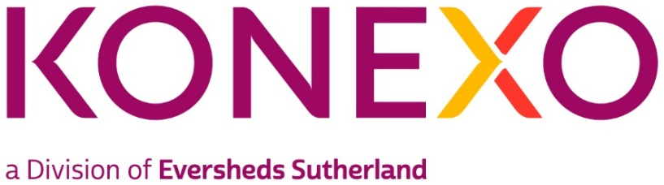

Senior Administrator, Konexo
Practice group/Global Operations team: Konexo
Type of Vacancy: Permanent
Full time/Part time: Full-Time
Location: Leeds
About Konexo
Konexo is a global alternative legal and compliance provider developed by Eversheds Sutherland offering Legal, Compliance and HR services. Through clever use of emerging technology and resources, we connect clients’ needs with real benefits, and meet their challenges with transformative solutions.
We combine the heritage, strength and stability of being developed by a global law firm, with a highly flexible approach to problem solving.
We offer a full range of services including consulting, legal services which includes managed services, branding services, real estate services and interim resourcing support - all underpinned by advanced technology, smart systems, and bright minds. Konexo is present in the UK, US, Hong Kong, Singapore and Malaysia
About the Team
The position of Senior Administrator is within Eversheds Sutherland, Konexo situated within the Legal Services department. Konexo meets the demand from in-house legal teams looking to outsource elements of their work. Our clients benefit from enhanced management information and new technology to help manage risk and balance workload. Konexo implementations are consulting led, which allows us to design end to end solutions to ensure effective delivery of legal services. We combine the technical expertise and resources of one of the world’s leading global law firms with excellence in management consultancy.
Within the team we employ professional lawyers, managers, operational process experts, paralegals and technology experts - combining together in highly effective structures, working with advanced technology. We embrace new working methodologies driving cost and quality improvements through our systematised case management approach. This eliminates waste whilst automating and simplifying processes.
The Role
The individual will report to the Team Leader and will be expected to work largely on their own initiative. For certain tasks they will be the initial escalation point for team players and client queries, whilst providing general support to the Team Leader and provide cover during periods of leave. An appetite to continuously develop the business and increase your knowledge of our clients is key. The individual will be expected to self-manage their own workload, assist with prioritising workloads for others and communicate effectively with management regarding deadlines/priorities.

- Creation and distribution of client-specific reporting
- Ad-Hoc reporting/queries
- Assist with monitoring the day-to-day operation of the team
- Build and maintain strong relationships with colleagues and clients
- Use initiative and point out any areas requiring attention/intervention

Skills and experience:
- Excellent communication skills, with the ability to engage with stakeholders of all levels
- Able to prioritise work to meet SLA's and deadlines.
- Adaptable and flexible
- Able to work without supervision and take full responsibility of own workload
- Able to effectively use existing knowledge and initiative to complete new tasks
- Proficient in the use of Microsoft and ALX systems
- Flexible to cross train on different client accounts
- Meticulous with a strong eye for detail
- Capable of establishing good working relationships with colleagues and clients
- Ability to extract information and present in a professional format
We are a modern, progressive law firm, who have built a culture where individual skills and personalities can shine through. At Konexo we believe that innovation comes from a culture of genuine equality and diversity and we are happy to discuss any reasonable adjustments individuals may require in the recruitment process, or once in post.
In addition to the above, Konexo also require awareness of and full participation in the Firm’s commitment to equality and diversity, the environment and health and safety.

