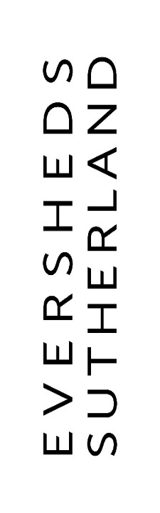
Associate and Senior Associate In Pensions
Practice Group/Global Operations team | ELPG
Full time/Part time | Full-time
Location | Birmingham
About Eversheds Sutherland
Eversheds Sutherland represents the combination of two firms with a shared culture and commitment to client service excellence. We are each known for our commercial awareness and industry knowledge and for providing innovative and tailored solution for every client.
As a full service law practice, we act for the public and private sector across the UK, Europe, Middle East, Africa, Asia and the US providing legal advice to clients across its company commercial, human resources, litigation and dispute management, and real estate practices.
With 69 offices across 35 countries worldwide, we have become one of the largest law practices in the world and a great place to work and develop your career.
The Team
Eversheds Sutherland has one of the largest and most respected employment, pensions and consultancy groups in the sector. Our work ranges from pensions to employment tribunals, and we advise the biggest financial institutions and government bodies. We also regularly handle headline cases, and much of what we do has a significant international dimension.
So as you might expect, ours is also an environment of extraordinary pace. Rapidly changing pensions and employment law requires us to be fleet of foot and highly responsive to the evolving operational, strategic and commercial needs of our clients. That takes more than strong technical expertise. It takes flexible professionals with the emotional intelligence to relate to clients, understand the unique challenges they face, and build successful long-term relationships.
Eversheds Sutherland’s pensions team has grown into a market leading force – both in the UK and across Europe. Most recently, as part of the FT Pension and Investment Provider Awards, the team won the “Twenty Years of Excellence” award, was highly commended in the “Pensions Law Firm of the Year” award category and won the Europen Pension Lawyers of the year 2020. The recognises the consistent long term presence of the team as got to pensions advisors.
Most recent Awards:
- European Pensions Awards 2020 - Law Firm of the Year
- Financial Times PIPA 2020 Commended, Pensions Law Firm of the Year
- Financial Times PIPA 2019 “Twenty Years of Excellence in Legal Advice” award in 2019
- Pension Law Firm of the Year 2018 & 2016 - Pensions Age Awards 2018 & 2016
- Pension Lawyers of the Year - Professional Pensions UK - Pensions Awards 2017
- Best Trustee Education Provider - Engaged Investor Awards 2016
Role
We have a position for a lawyer ideally in the 3 - 6 years’ PQE range. We would be very happy to hear from applicants who have worked in industry and who wish to return to private practice or from applicants looking for part-time or flexible working posts.
The successful candidate will be responsive to clients have a “can-do” approach and enjoy working as part of a team.
We're a modern, progressive law firm. We think differently and we've built a culture where individual skills and personalities can shine through. At Eversheds Sutherland, we believe that innovation comes from a culture of genuine equality and diversity and we are happy to discuss any reasonable adjustments individuals may require in the recruitment process, or once in post.
Why Us?
- Agile – Flexible working opportunities
- Benefits – Comprehensive benefits package
- Corporate Social Responsibility (CSR) – Charitable trusts and volunteering
- Culture – Wellbeing, supportive, inclusive and diverse
- Innovation – Winner of a number of Innovation Awards
- Opportunities – Development, mentoring, STEP training programme and secondments
- Reputation – UK’s strongest law brand

Values
Together we are
We leverage our collective talents for the benefit of our clients and each other and we prize teamwork and relationships. | We are innovative and creative problem-solvers, providing an enhanced client and employee experience by not being bound by custom or convention. | We deliver quality and excellence and act with the utmost integrity at all times.

We foster a diverse and inclusive culture that places respect and support for everyone at its core and empowers all our people to fulfill their potential. | We are approachable and nurture a culture of transparency and openness.

Diversity and Inclusion
At Eversheds Sutherland, we recognise that having diverse talent across our business brings many benefits, and we are committed to accessing a wide range of views and thinking in all that we do. A culture of inclusion, where each person feels able to be their true self at work and reach their full potential is key. We recognise that bringing together the perspectives of individuals of all backgrounds, life experiences, preferences and beliefs is critical if we are to serve our global client base, people and communities as a leading global legal practice.
We are happy to discuss any reasonable adjustments individuals may require at any stage of the recruitment process, and as part of joining our team. We are also open to talking about flexible working for our roles. Please get in touch with a member of our recruitment team if you would like to discuss anything or have any questions about the process and we will be happy to assist.

