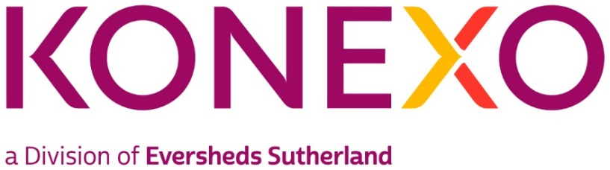

Talent Engagement Executive
Practice group/Global Operations team: Konexo Legal Resourcing
Type of Vacancy: Permanent
Full time/Part time: Full-Time
Location: London
About Konexo
Konexo (https://www.konexoglobal.com/) is a global alternative legal and compliance services provider, developed by Eversheds Sutherland. It has a legal resourcing offering, created to meet client demand for high quality, interim legal, company secretarial, HR and compliance professionals. We provide peace of mind with exceptional legal talent and the support of one of the largest and most innovative law firms in the world.
Konexo legal resourcing continues to grow both in the UK and internationally. We provide lawyers, paralegals, project managers and legal compliance consultants to some of the world’s largest companies. Our consultants operate onsite at our client’s offices, remotely and also support Eversheds Sutherland teams both onsite and virtually. They can be full time, part time, and even provide ad hoc support for a number of hours per week
The Role
To meet significant growth, we are looking for a Konexo Talent Engagement Executive to provide support to the existing Konexo Legal Resourcing team, ensuring our legal talent pipeline is strong to meet client demand.
The position is a varied role and would suit someone with existing resourcing experience, however if you don’t have the experience, we are interested in individuals that are ambitious, competitive and looking to start a career within the recruitment/legal industry.
Key Responsibilities
- Support the Talent Engagement Consultant to assist with the building and execution of recruitment campaigns to source the best legal professional talent in the UK.
- Utilising technology such as Linkedin Recruiter, our referral network and social media channels to manage candidate sourcing and relationships.
- Managing the data and analytics around candidate sourcing activity to present to the Talent Engagement Consultant and the wider stakeholders in the business.
- Act as the first point of contact to all candidates by undertaking initial screening calls.

- Undertake candidate onboarding processes including using our ATS system, application form and CV tracking, interview scheduling and onboarding to our Konexo Consultant App.
- Arrange interviews with candidates with our Talent Engagement Consultant and subject matter experts in Eversheds Sutherland.
Skills and experience:
- We are keen to hear from you if you have a background either in house or agency as a recruitment administrator, researcher or resourcer – working within Legal recruitment will be an advantage but not essential
- Attention to detail and good time management skills are a must in this role. As you will be managing your own projects, the ability to prioritise is key!
- A can do attitude is also essential. We are a very collaborative team, where everyone has a voice and your input will be valued.
- Ability to work effectively with colleagues from a variety of backgrounds and experience levels.
Key Competencies:
- Meticulous attention for detail and desire/willingness to be flexible to support others
- An approachable manner, used to building rapport across all areas of engagement
- Experience of working with multiple senior stakeholders across a business; Partners/Recruitment Directors/Marketing.
- An ambitious, confident, client focused professional with a practical can-do mentality.
- A good understanding and practical experience of recruitment.
- Excellent IT skills especially in using Microsoft Office suite.
- Pro-active, with strong ability to manage time effectively.
Salary Range: Competitive

